select e.empname , d.dname , d.dloc
from employee e , dept d
where e.deptno = d.deptno ;


select e.empname from employee e
where e.empno not in (select empno from assigned_to);
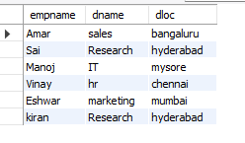
SELECT p.pname, COUNT(a.empno) AS headcount
FROM project p
LEFT JOIN assigned_to a ON p.pno = a.pno
GROUP BY p.pname;


select d.dname , avg(e.sal) as avg_salary , max(e.sal) as max_salary
from dept d
left join employee e on d.deptno
group by d.dname;

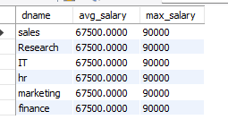

SELECT e.empname, p.pname
FROM employee e
JOIN assigned_to a ON e.empno = a.empno
JOIN project p ON a.pno = p.pno
WHERE p.pname = 'Alpha Project';


SELECT d.dname, d.dloc
FROM dept d
LEFT JOIN employee e
ON d.deptno = e.deptno
WHERE e.empno IS NULL;



SELECT e.empname, COUNT(a.pno) AS project_count
FROM employee e
JOIN assigned_to a
ON e.empno = a.empno
GROUP BY e.empname
HAVING COUNT(a.pno) > 1;
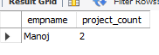

select e.empname , sum(i.incentives_amt) as total_incentives from employee e
left join incentives i on e.empno = i.empno
group by e.empname
order by total_incentives desc;

